Data Assembly JSON Filteration and CSV Creation
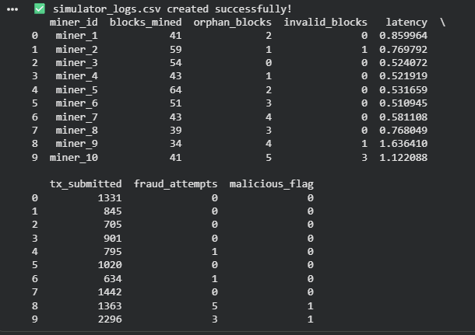
Objective 1 & 2
Data loading
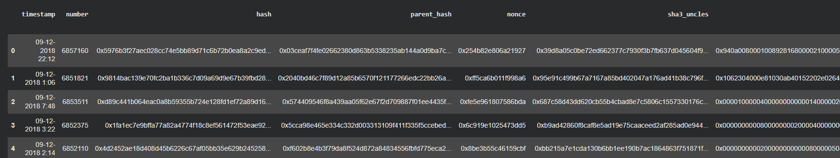
Data info
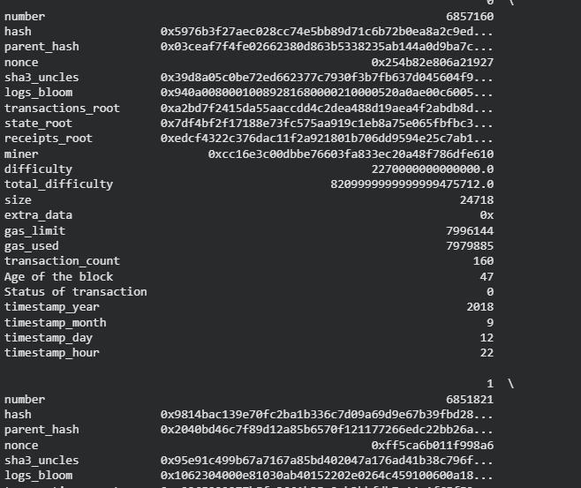
Feature Selection and Extraction
Histogram Analysis
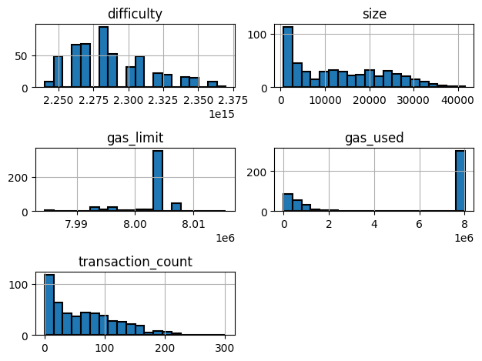
Scatter map
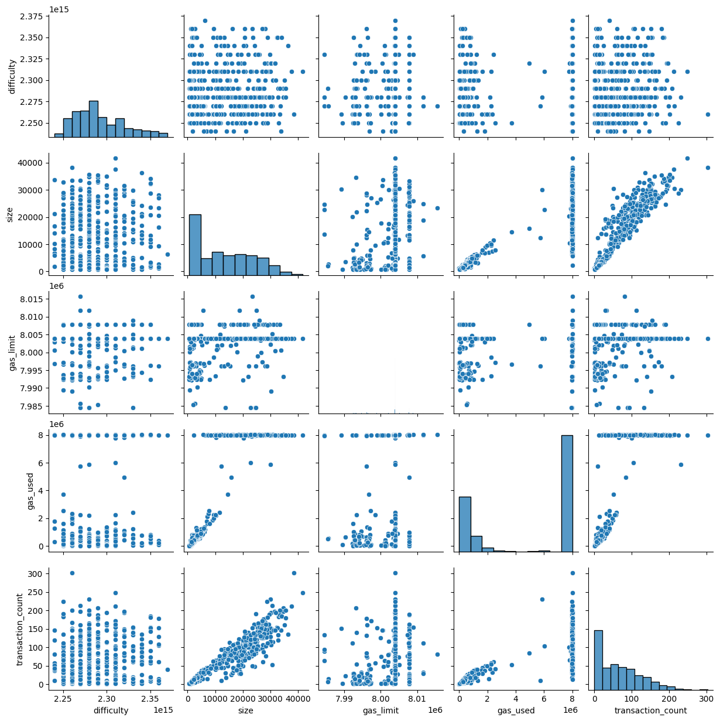
Correlation Coefficient
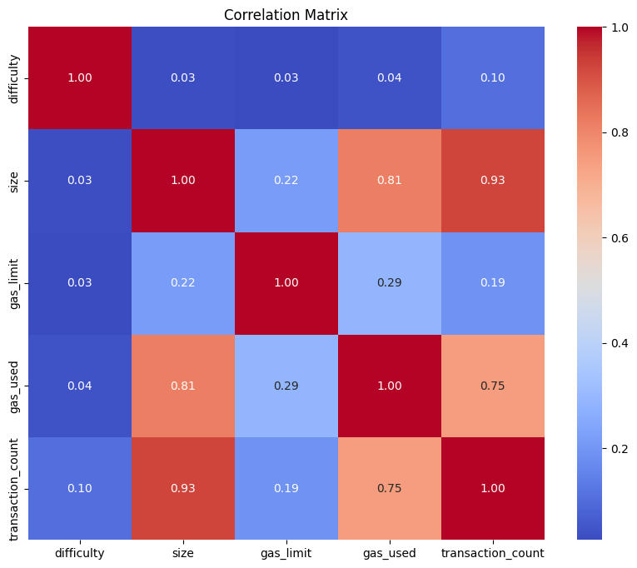
Correlation After Normalisation
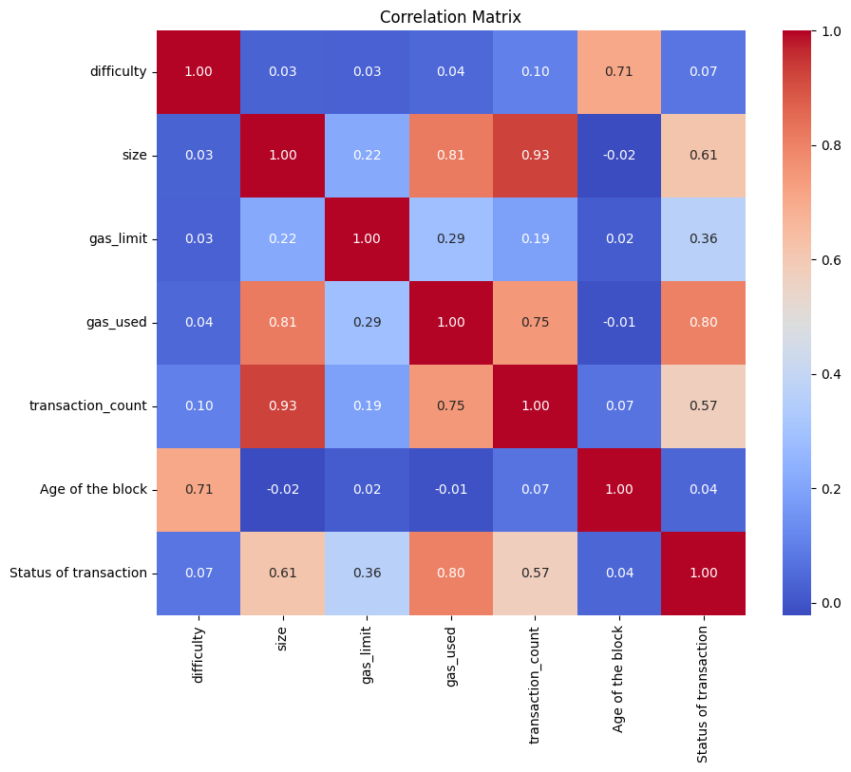

Base Execution Age of the block prediction
Random Forrest
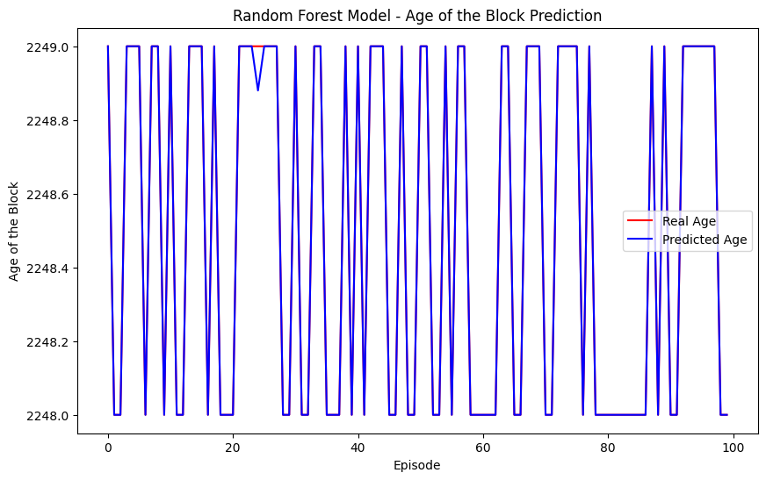
Random Forest Model:
R-squared accuracy: 0.9994240000000011
Decentralization (Age between 2248.00 and 2249.00): 100.0%

Gradient Boosting
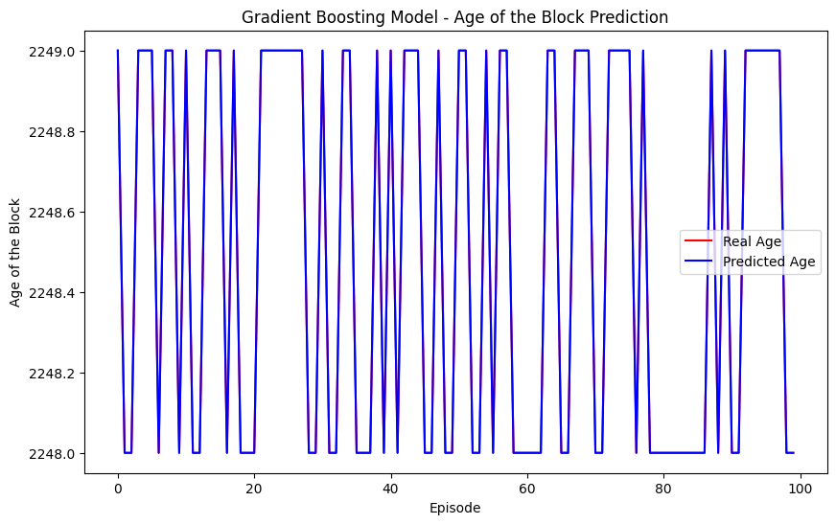
Gradient Boosting Model:
R-squared accuracy: 0.9999999992944215
Decentralization (Age between 2248.00 and 2249.00): 100.0%
SVR
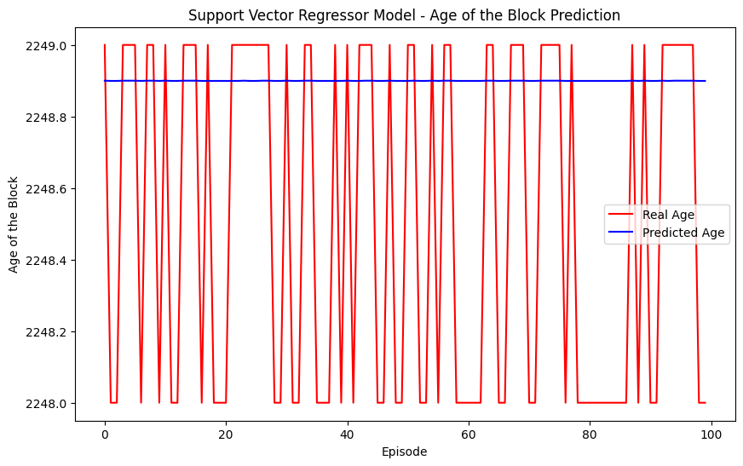
Support Vector Regressor Model:
R-squared accuracy: -0.6379493056132224
Decentralization (Age between 2248.00 and 2249.00): 100.0%
Liner Regression
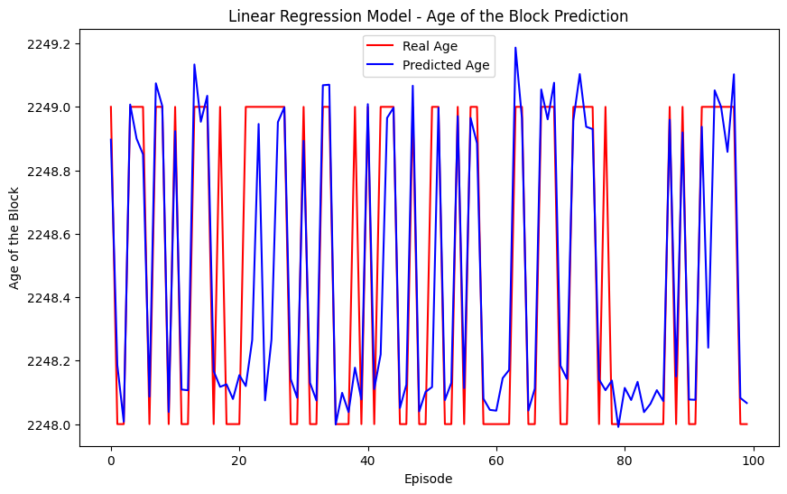
Linear Regression Model:
R-squared accuracy: 0.6912279121308131
Decentralization (Age between 2248.00 and 2249.00): 83.0%

Consolidated Evaluation
Model Evaluation Results:
Random Forest: R-squared = 0.9994240000000011, Decentralization = 100.0%
Gradient Boosting: R-squared = 0.9999999992944215, Decentralization = 100.0%
Support Vector Regressor: R-squared = -0.6379493056132224, Decentralization = 100.0%
Linear Regression: R-squared = 0.6912279121308131, Decentralization = 83.0%

Re-Enforcement Learning Process
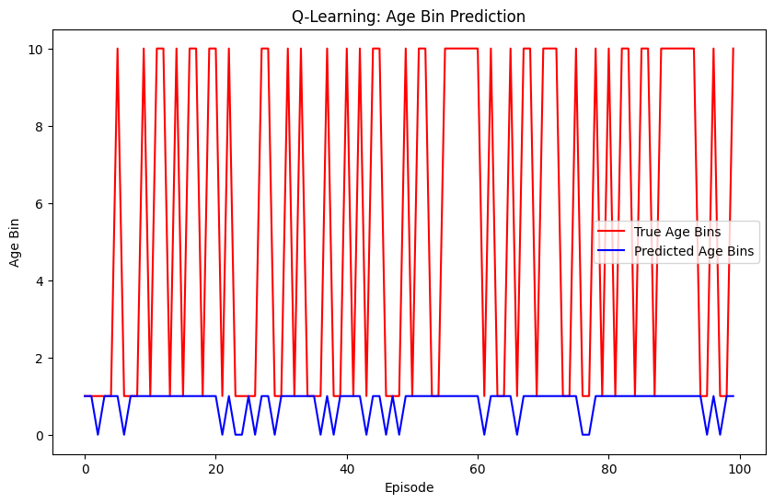
Average Reward: -4.68
Accuracy: 32.0%
Decentralization: 82.0%
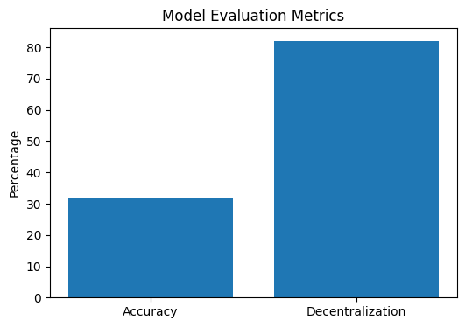

Comparison Matrices
Random Forest - R-squared: -0.1434, MAE: 0.5042, MSE: 0.2840
Gradient Boosting - R-squared: -0.1342, MAE: 0.4968, MSE: 0.2817
Support Vector Regressor - R-squared: -0.5217, MAE: 0.4680, MSE: 0.3780
Linear Regression - R-squared: -0.0215, MAE: 0.4986, MSE: 0.2537
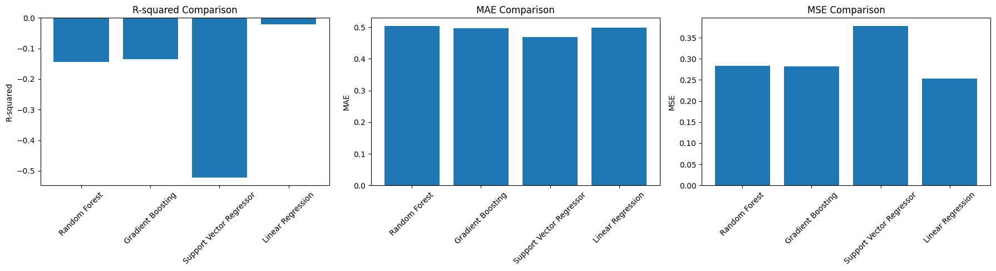
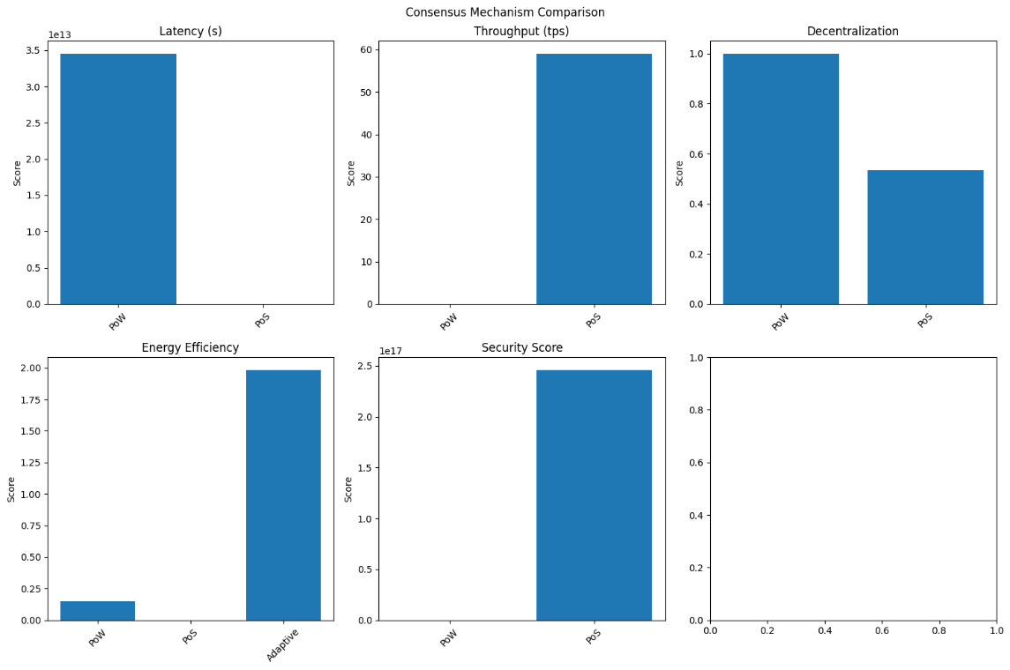
Block Based Matrices for Same Comparision
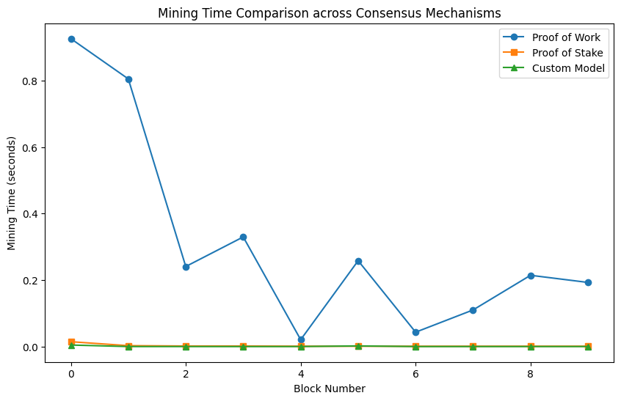

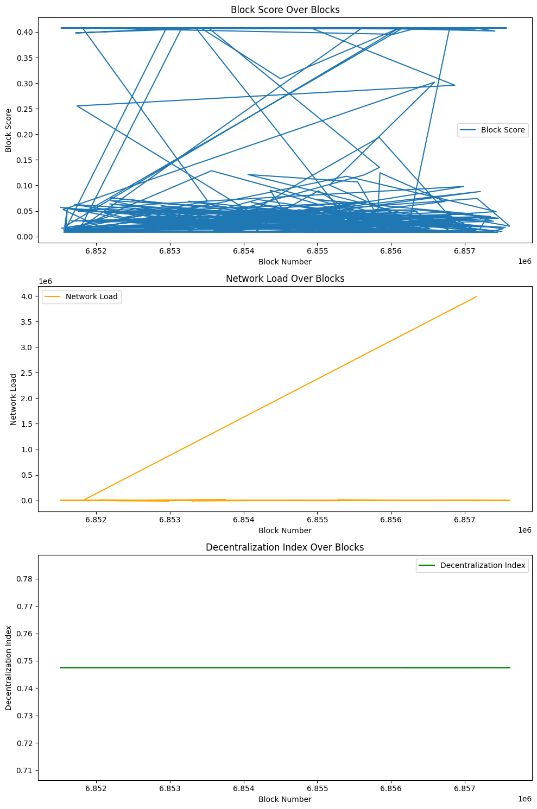

Objective 3 & 4
Ensemble Technique Updates
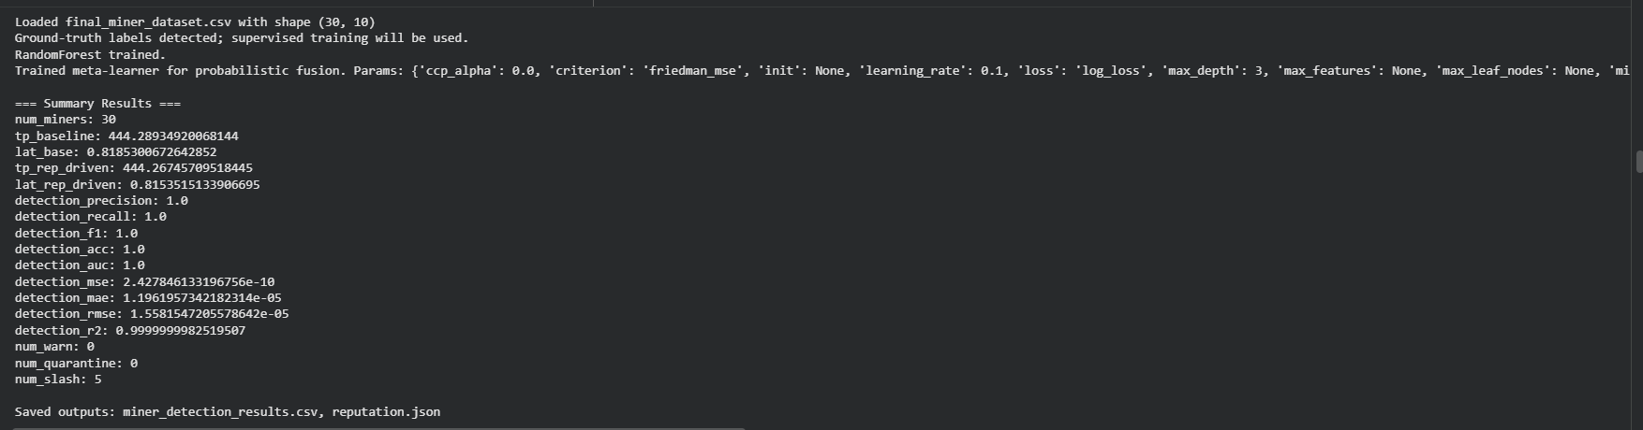
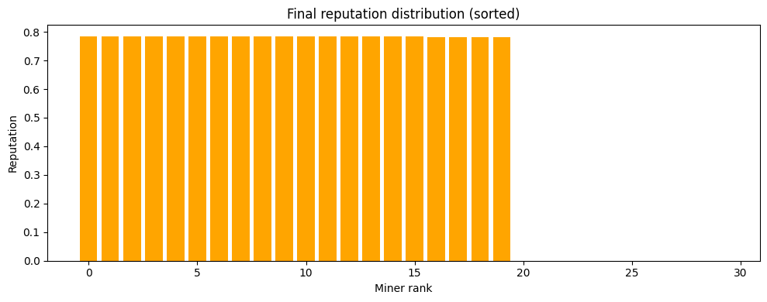
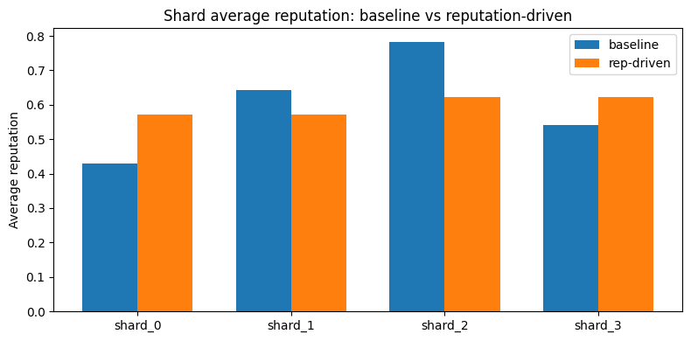
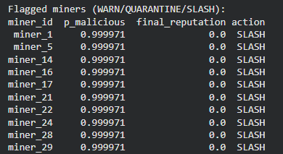
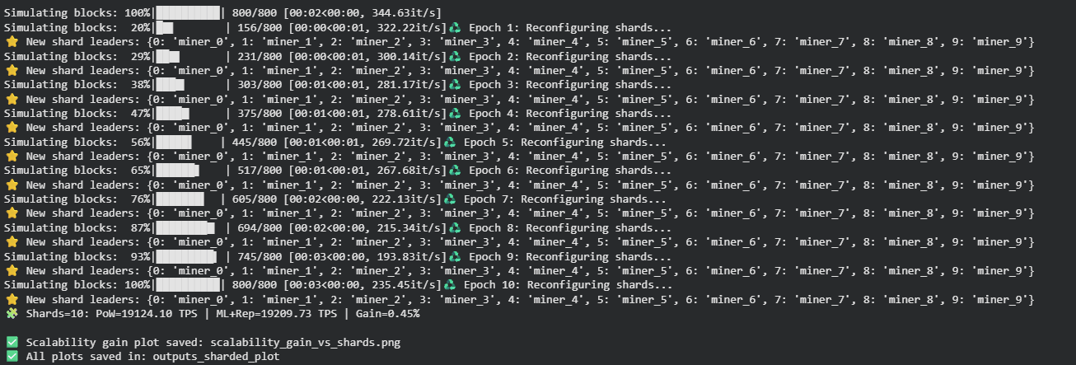
Simulation For Each Block and Data using Same Technique
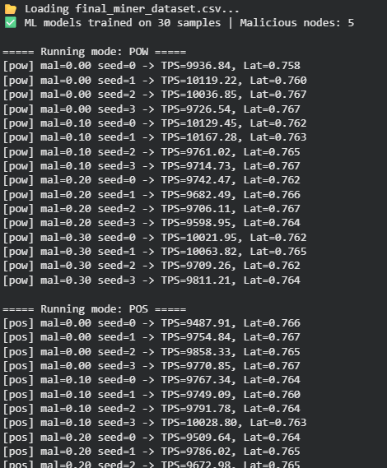
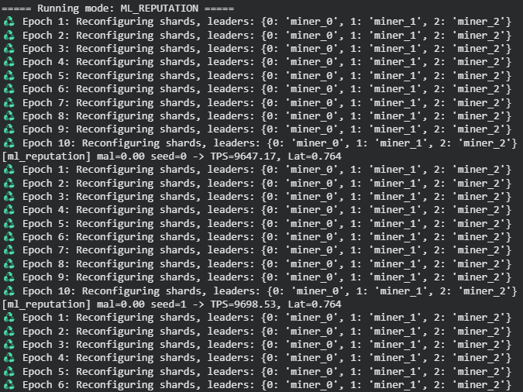
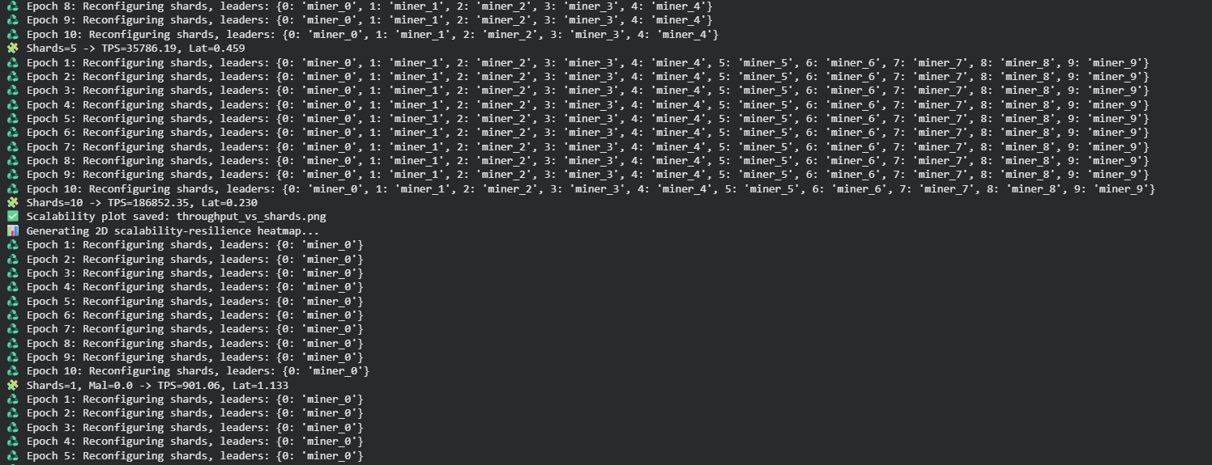
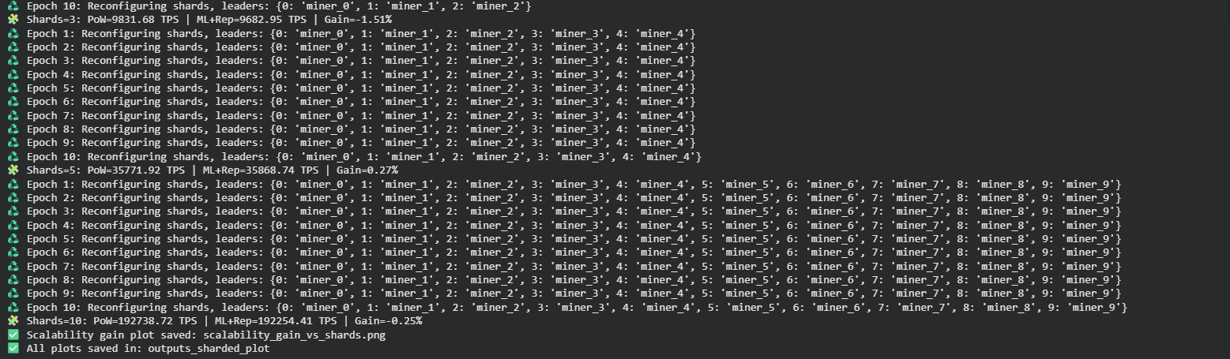
Matrices
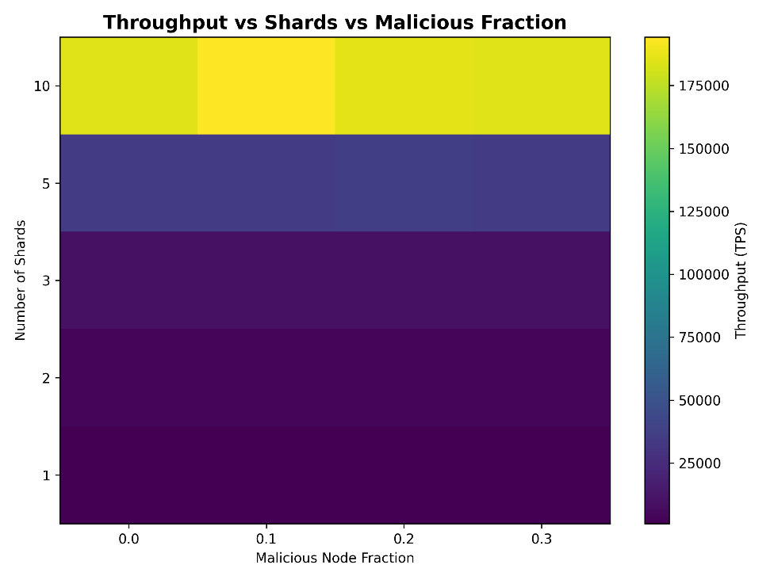
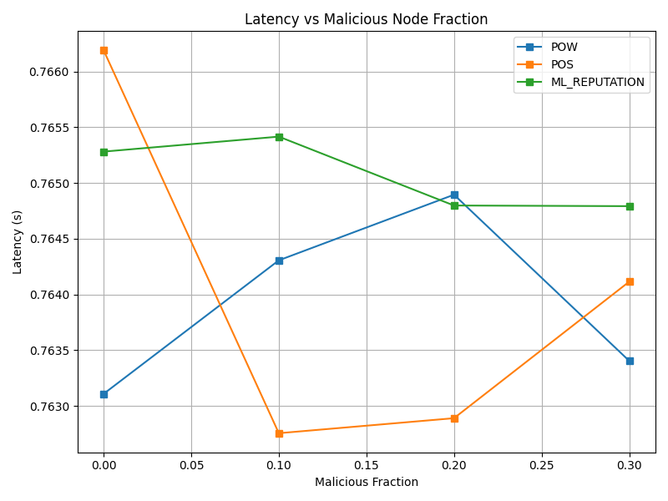
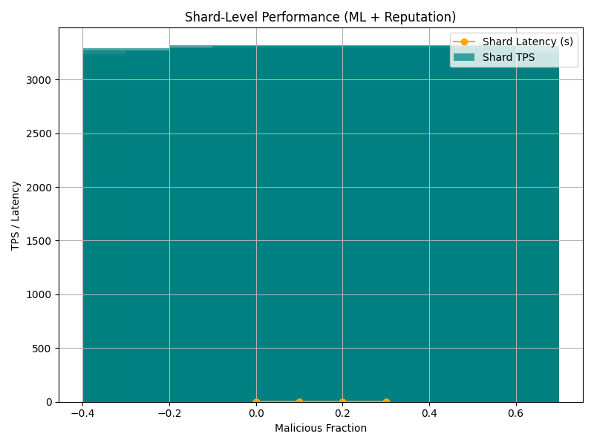
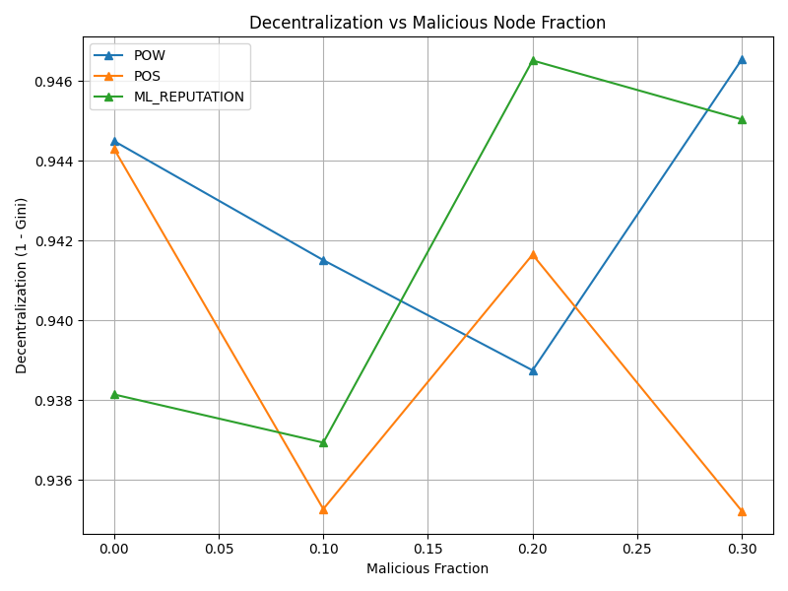
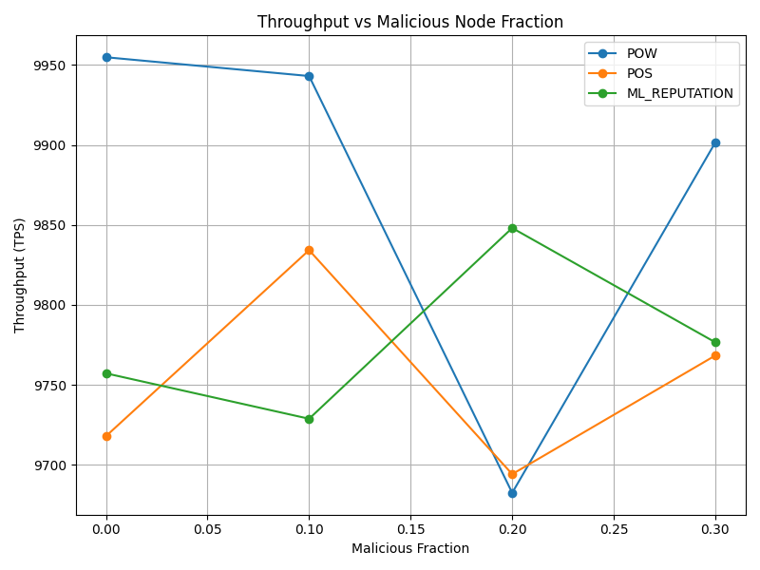
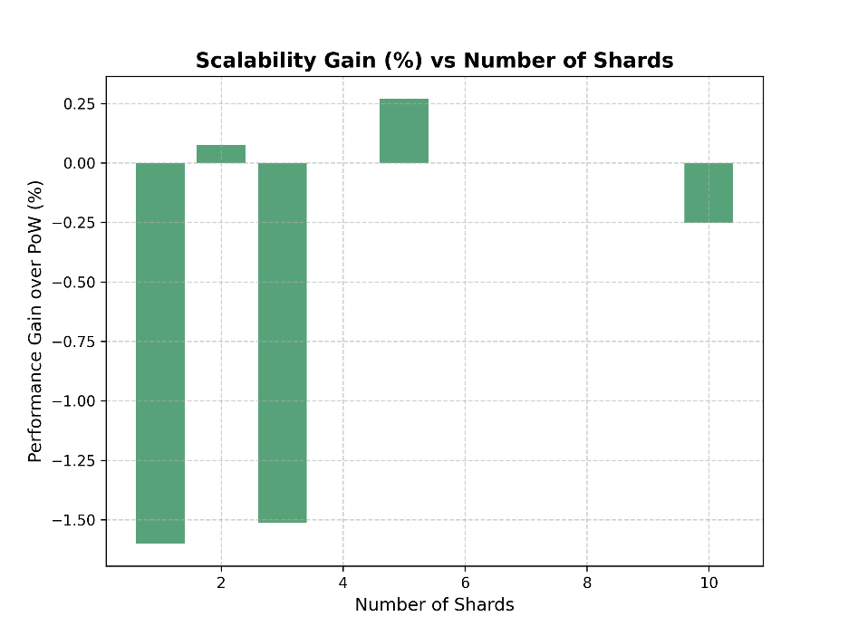
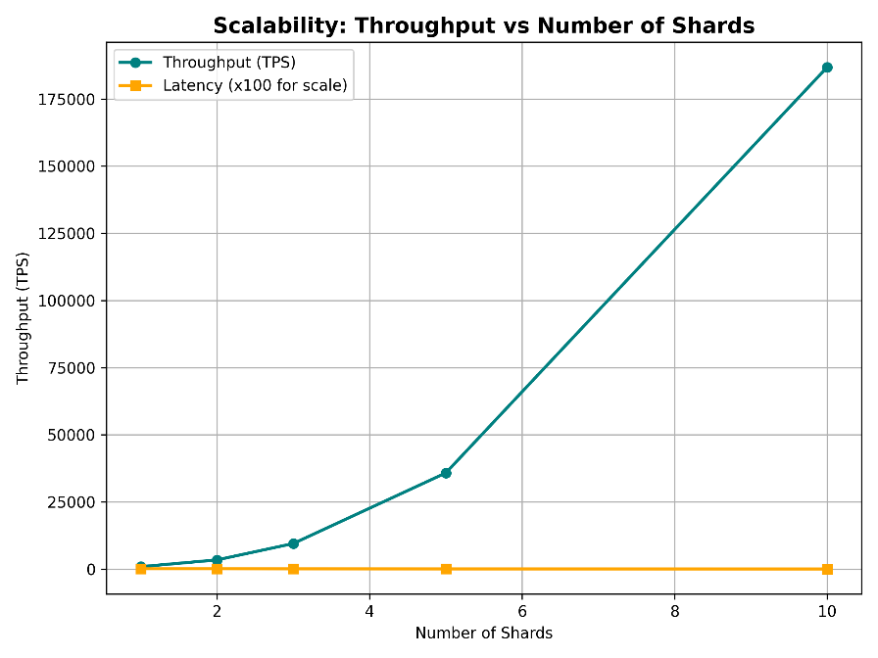
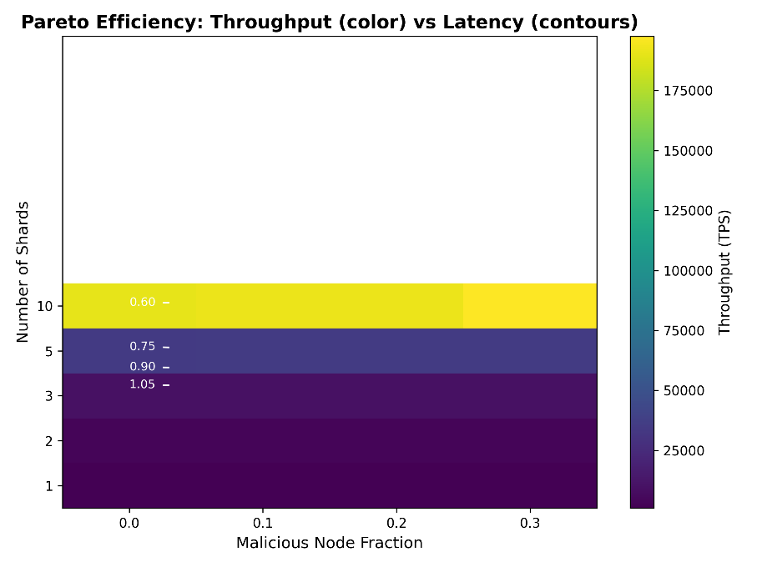

Objective 4
Decentralised Simulation Execution
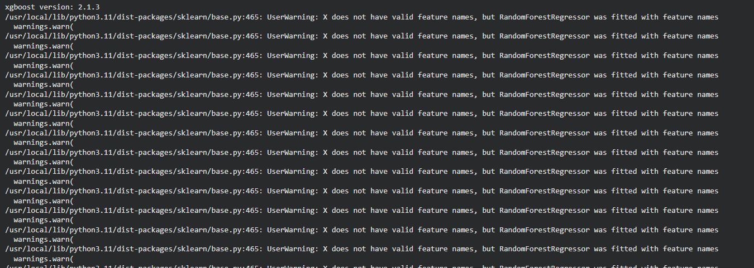
Simulation Results Creation
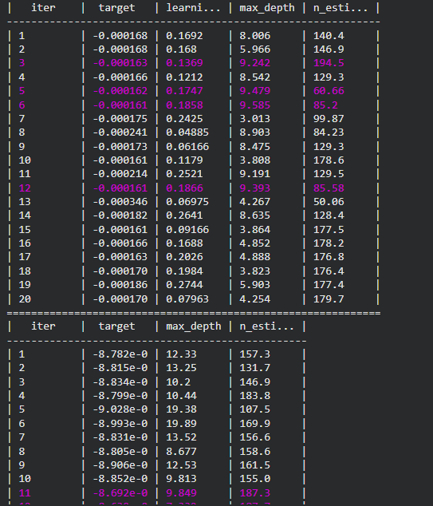
MAE Comparison
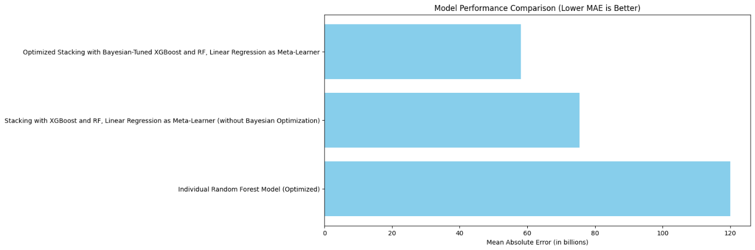
Node Analysis
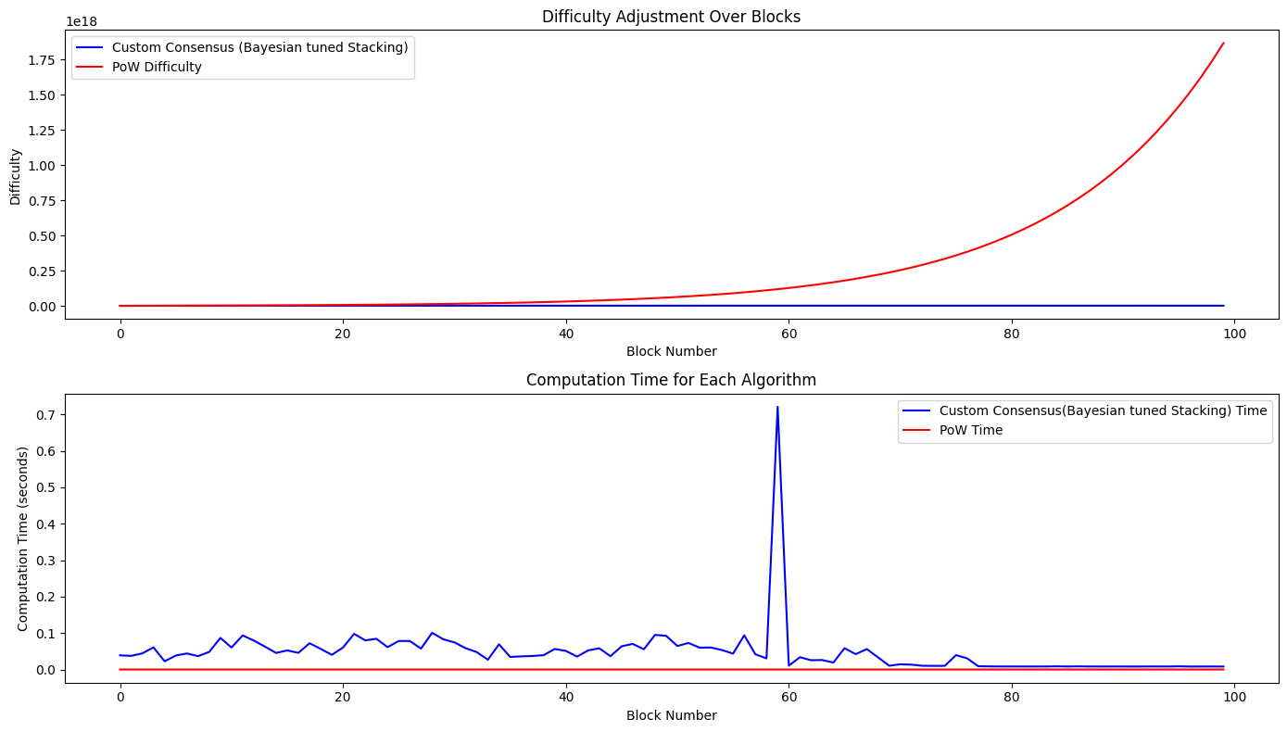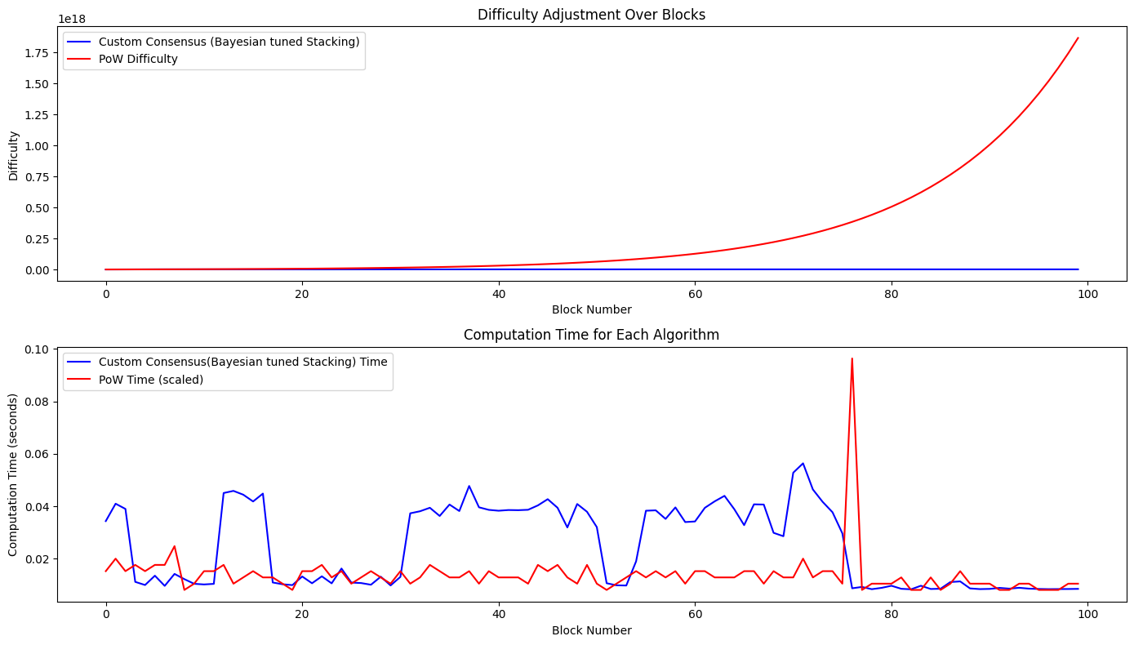
Monitoring during Blockchain Node Execution
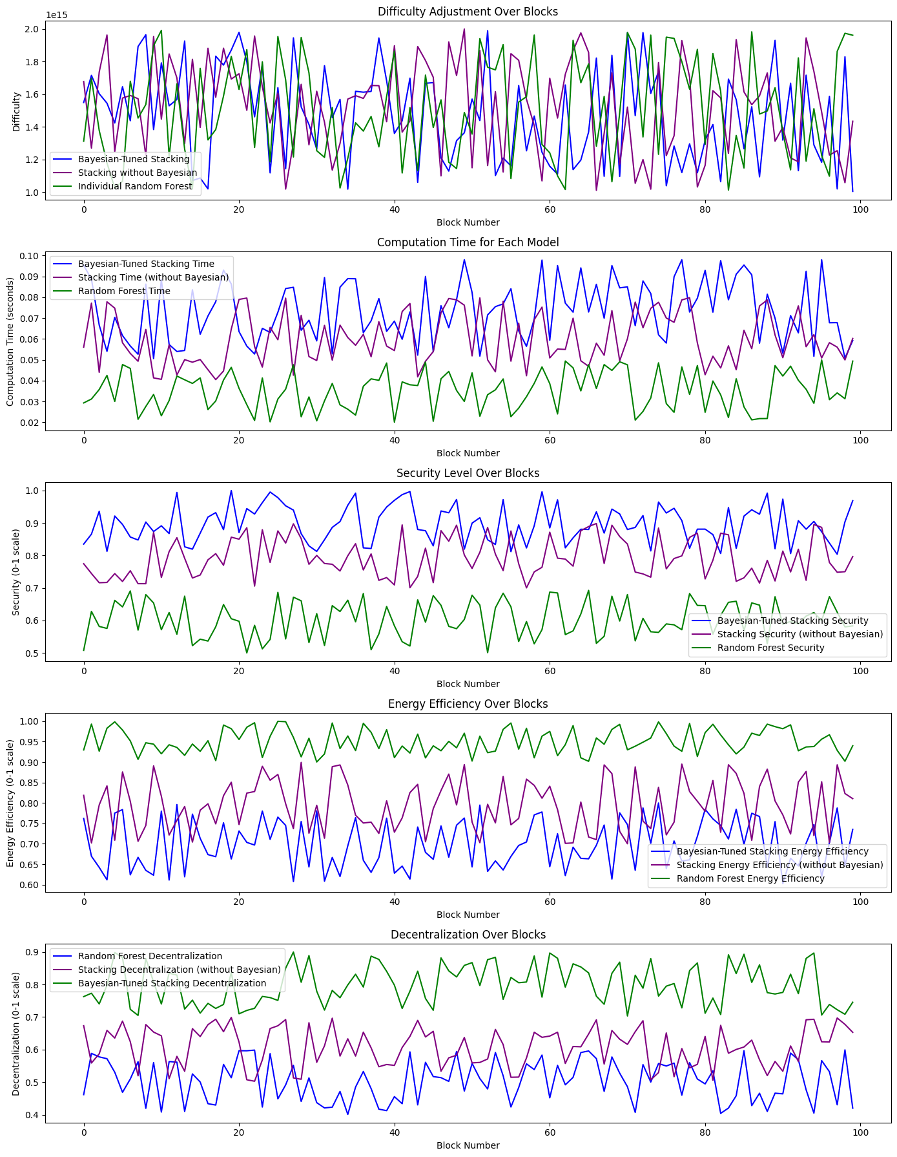
Latency and Throughput monitoring graph
